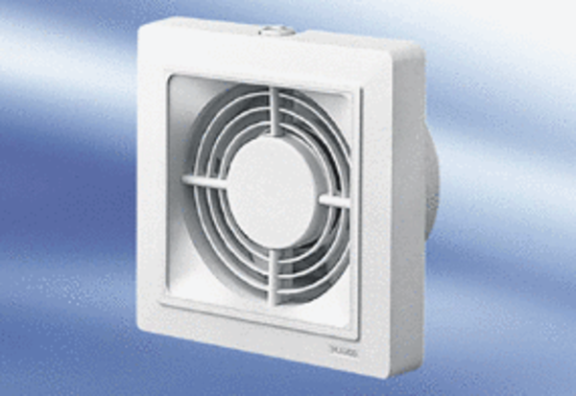Small room fan ECA 15/4Packing unit: 1 pieceRange:
Article number: 0080.0971Manufacturer: MAICO

