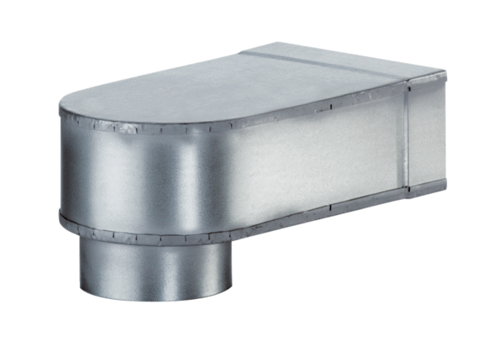Bracket MF-W100 80/150Packing unit: 1 pieceRange: K
Article number: 0018.0494Manufacturer: MAICO

