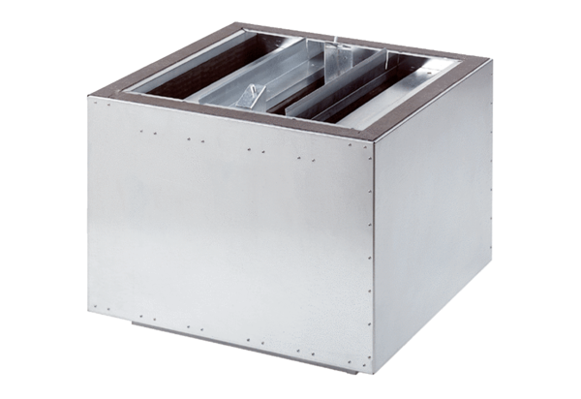Exhaust air silencer SDA 63Packing unit: 1 pieceRange:
Article number: 0092.0393ALTManufacturer: MAICO

