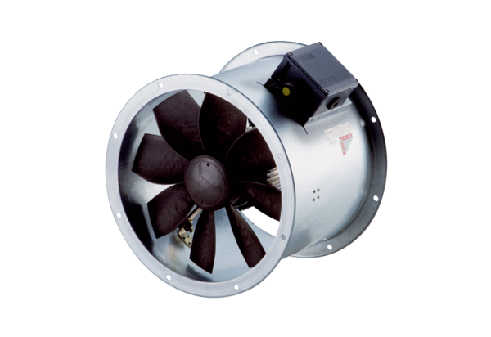Axial duct fan DZR 40/4 B Ex tPacking unit: 1 pieceRange: C
Article number: 0086.0730Manufacturer: MAICO

