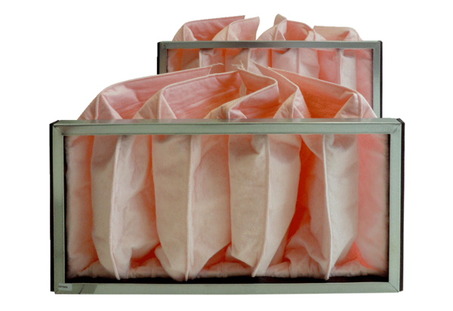Air filter, replacement KF 25-7Packing unit: 2 piecesRange: D
Article number: 0093.0864Manufacturer: MAICO

