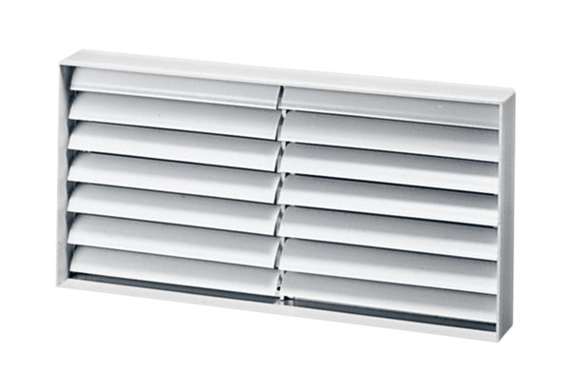Channel shutter AKP 22Packing unit: 1 pieceRange: D
Article number: 0151.0096Manufacturer: MAICO

