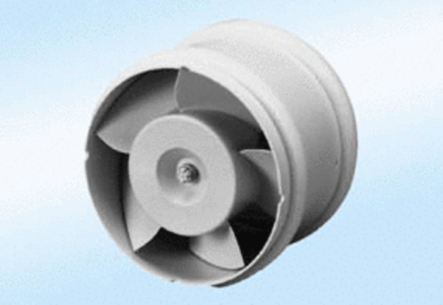Duct-mounted fan ECA 15/2 E 24 VPacking unit: 1 pieceRange: A
Article number: 0080.0992Manufacturer: MAICO

