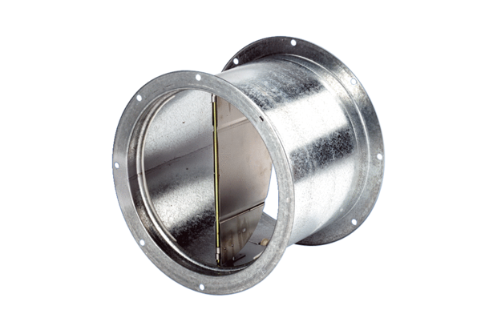Shutter, pull device VD 60Packing unit: 1 pieceRange: C
Article number: 0093.0108Manufacturer: MAICO

