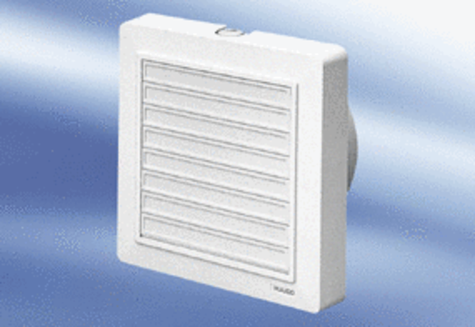Small room fan ECA 15/4 KPacking unit: 1 pieceRange:
Article number: 0080.0973Manufacturer: MAICO

