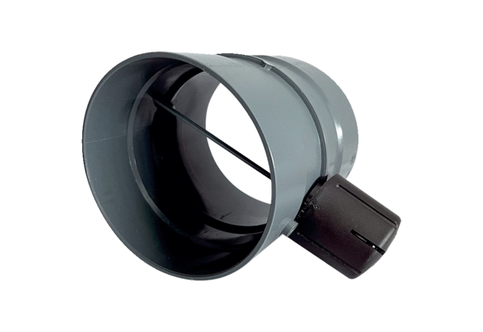Manual throttle valve MDKI 35Packing unit: 1 pieceRange: C
Article number: 0073.0484Manufacturer: MAICO

