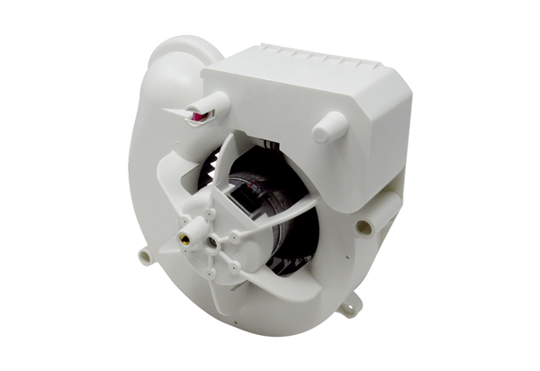Fan insert VE ER-APB 60 HRange: B
Article number: E084.0160.0000Manufacturer: MAICO

