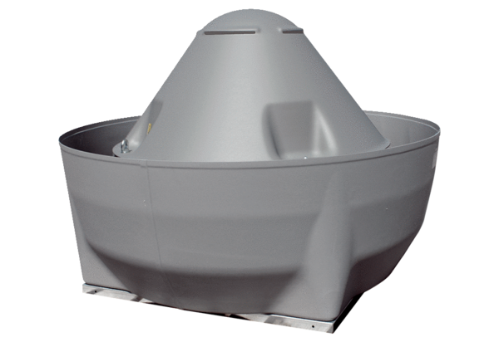Centrifugal roof fan DRD V 63/6Packing unit: 1 pieceRange: C
Article number: 0073.0070Manufacturer: MAICO

