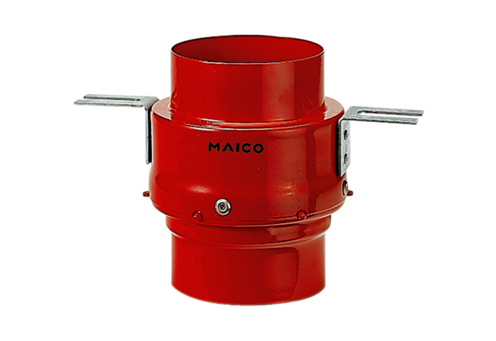Fire protection ceiling barrier TS 18 DN 140Packing unit: 1 pieceRange: B
Article number: 0151.0322Manufacturer: MAICO

