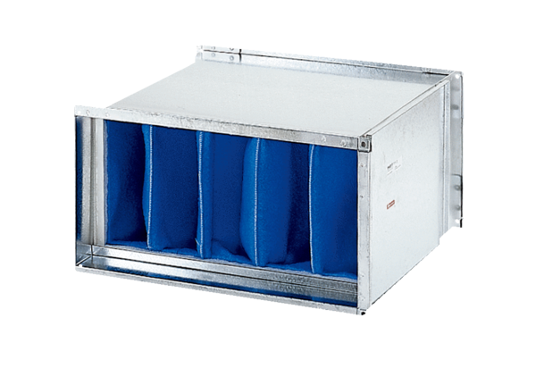Air filter TFP 35-7Packing unit: 1 pieceRange: D
Article number: 0149.0071Manufacturer: MAICO

