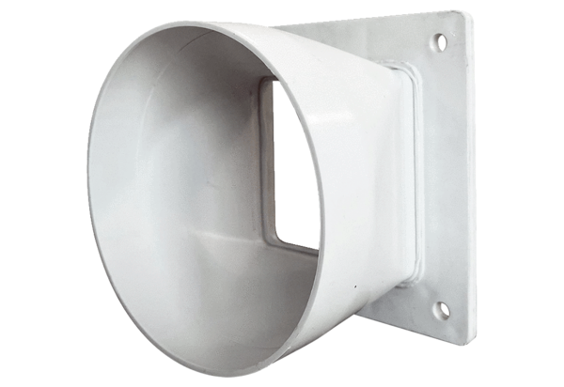Transition adapter URRI GR 20Packing unit: 1 pieceRange: C
Article number: 0073.0312Manufacturer: MAICO

