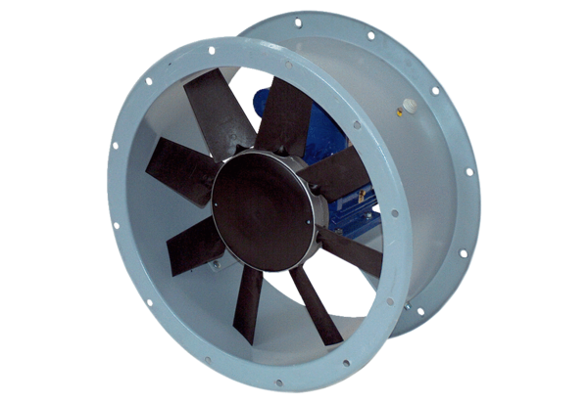Axial duct fan DAR 160/6 15Packing unit: 1 pieceRange: C
Article number: 0073.0196Manufacturer: MAICO

