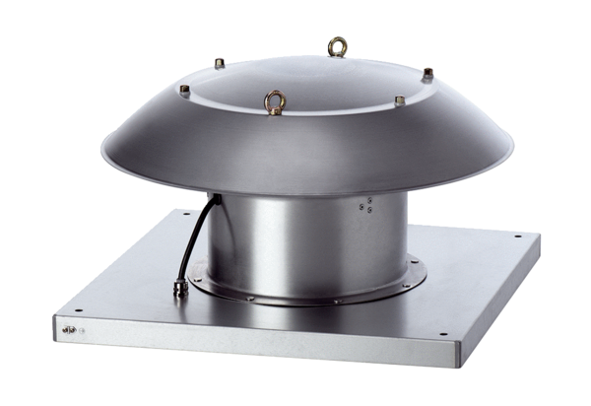Axial roof fan DZD 30/4 B Ex tPacking unit: 1 pieceRange: C
Article number: 0087.0813Manufacturer: MAICO

