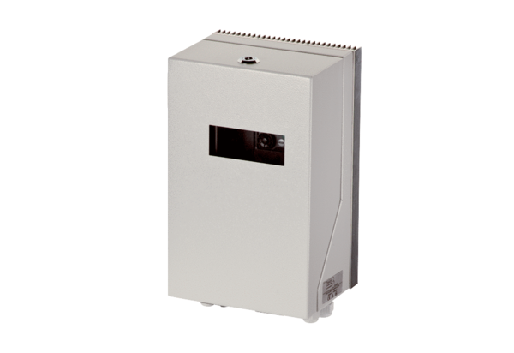Frequency converter MFU 19Packing unit: 1 pieceRange: C
Article number: 0157.1220Manufacturer: MAICO

