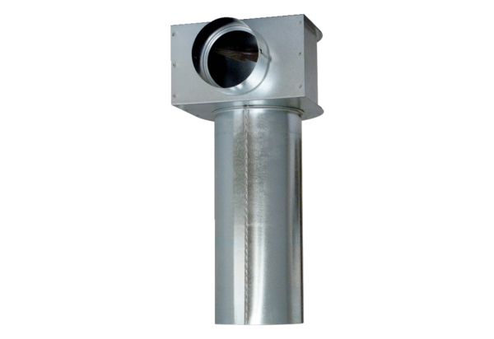Bracket MF-WLF125/90Packing unit: 1 pieceRange: K
Article number: 0018.0529Manufacturer: MAICO

