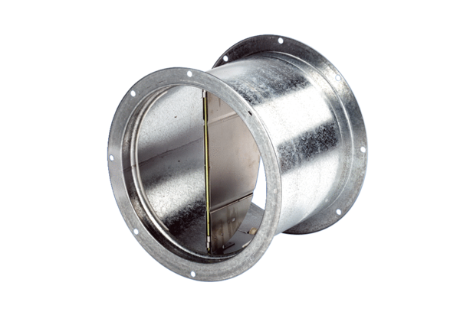Shutter, pull device VD 35Packing unit: 1 pieceRange: C
Article number: 0093.0103Manufacturer: MAICO

