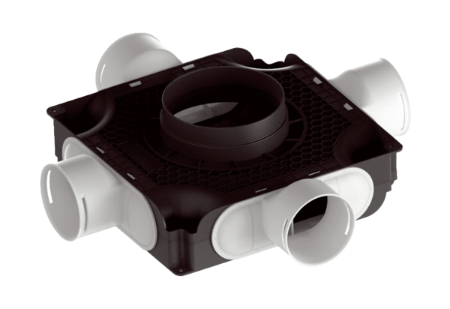Flat, compact air distributor made of plastic, 4-way MA-FV4-90Packing unit: 1 pieceRange: K
Article number: 0059.2126Manufacturer: MAICO

