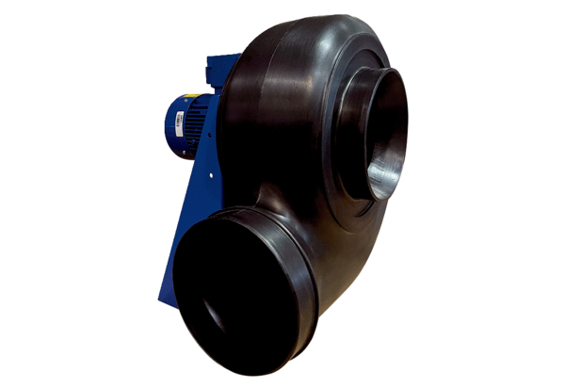Centrifugal blower GRK R 50/6 D ExPacking unit: 1 pieceRange: C
Article number: 0073.0457Manufacturer: MAICO

