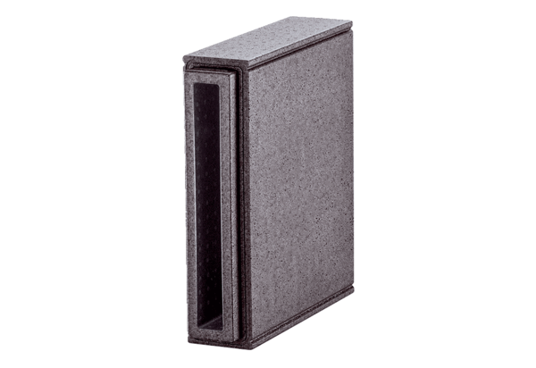Soffit element extension PP 45 LEVPacking unit: 1 pieceRange: K
Article number: 0093.1483Manufacturer: MAICO

