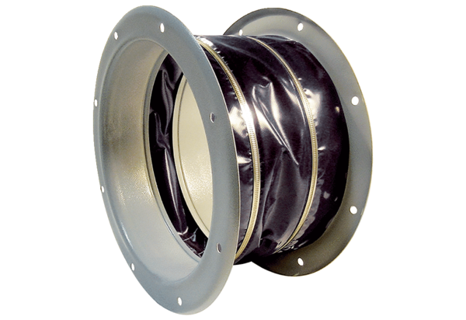Flexible coupling ELI 90 ExPacking unit: 1 pieceRange: C
Article number: 0073.0581Manufacturer: MAICO

