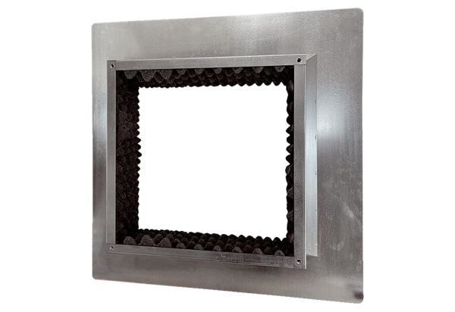Roof socket insulated, for flat roofs SOFI 35Packing unit: 1 pieceRange: C
Article number: 0073.0048Manufacturer: MAICO

