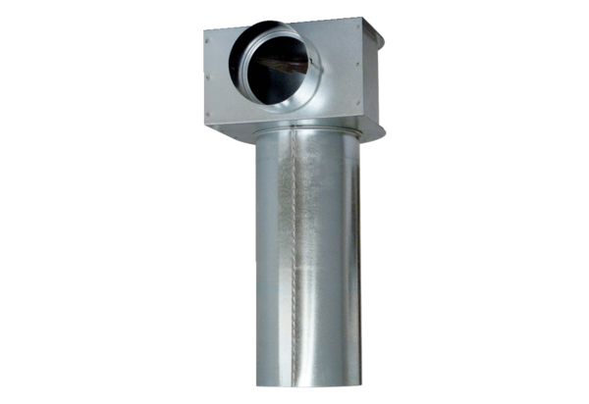Bracket MF-WLF100/90Packing unit: 1 pieceRange: K
Article number: 0018.0607Manufacturer: MAICO

