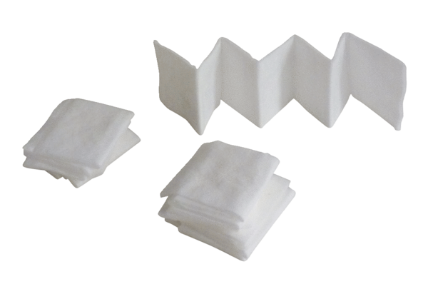Air filter, replacement PF 100Packing unit: 5 piecesRange: D
Article number: 0093.0651Manufacturer: MAICO

