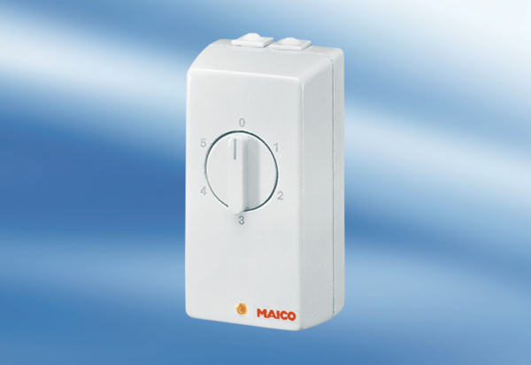TRE 0,4Packing unit: 1 pieceRange: C
Article number: 0016.0110Manufacturer: MAICO

