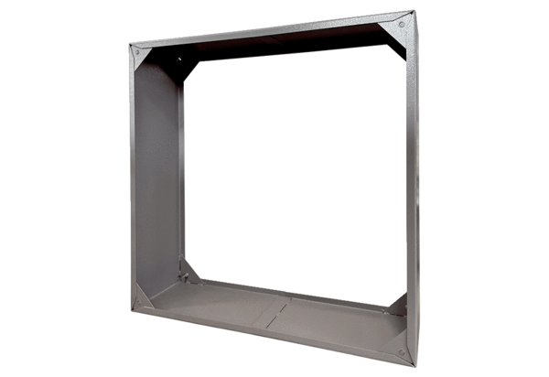Connection frame VRI 63Packing unit: 1 pieceRange: C
Article number: 0073.0340Manufacturer: MAICO

