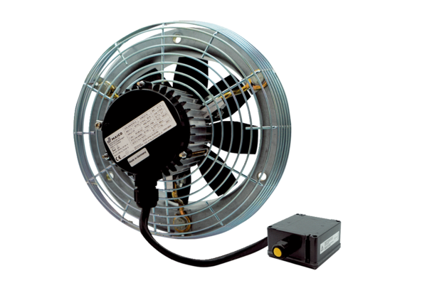Axial wall fan DZS 35/2 B Ex tPacking unit: 1 pieceRange: C
Article number: 0094.0210Manufacturer: MAICO

