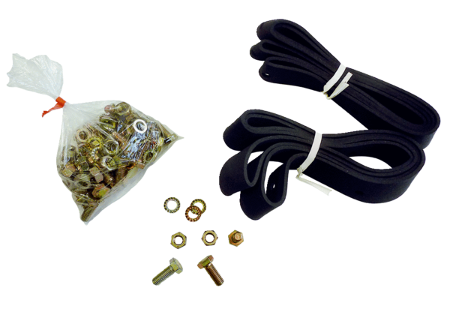Mounting and sealing material BD 40Packing unit: 1 pieceRange: C
Article number: 0092.0136Manufacturer: MAICO

