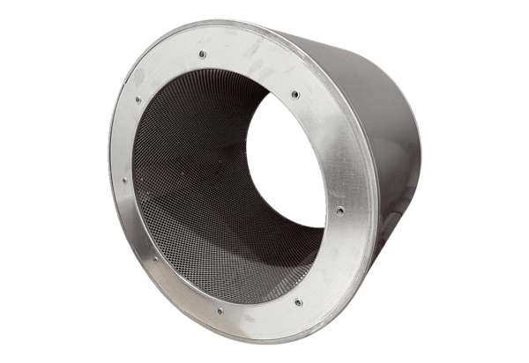Tubular sound absorber RSI 71/1000Packing unit: 1 pieceRange: C
Article number: 0073.0100Manufacturer: MAICO

