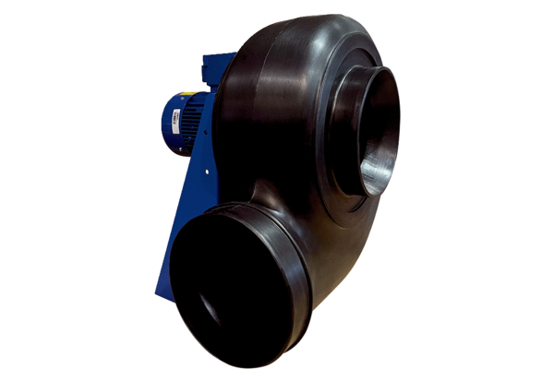Centrifugal blower GRK R 31/6 D ExPacking unit: 1 pieceRange: C
Article number: 0073.0448Manufacturer: MAICO

