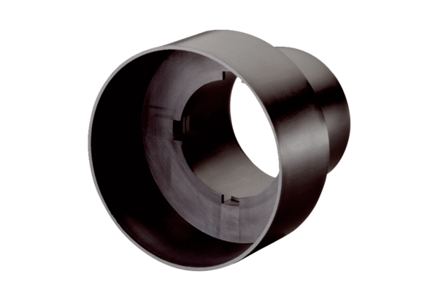Valve adaptor MF-A75Packing unit: 1 pieceRange: K
Article number: 0059.0964Manufacturer: MAICO

