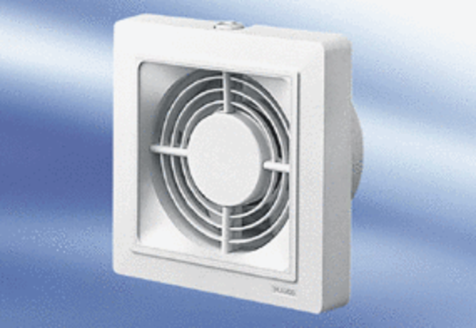Small room fan ECA 15/4 VZPacking unit: 1 pieceRange:
Article number: 0080.0981Manufacturer: MAICO

