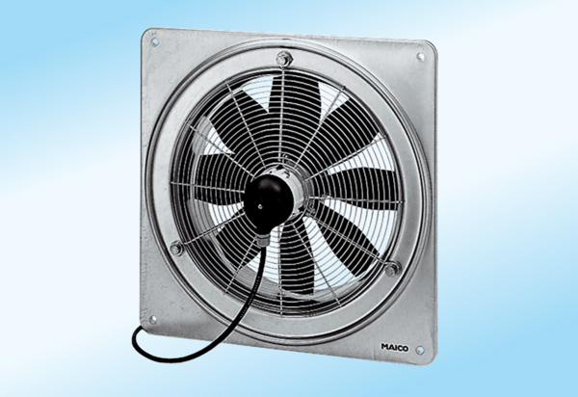Axial wall fan DZQ 50/4 A-ExPacking unit: 1 pieceRange: C
Article number: 0083.0786Manufacturer: MAICO

