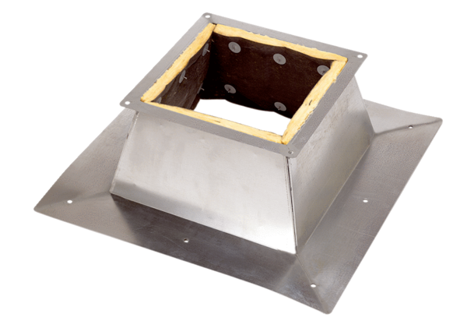Roof socket for flat roofs SO 50Packing unit: 1 pieceRange: C
Article number: 0093.0364Manufacturer: MAICO

