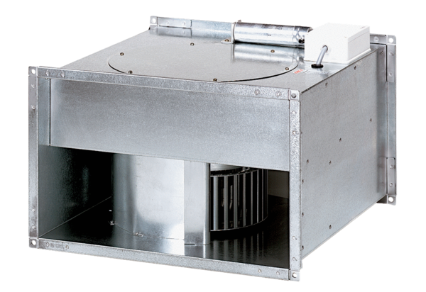Channel fan DPK 35/4 BPacking unit: 1 pieceRange: D
Article number: 0086.0669Manufacturer: MAICO

