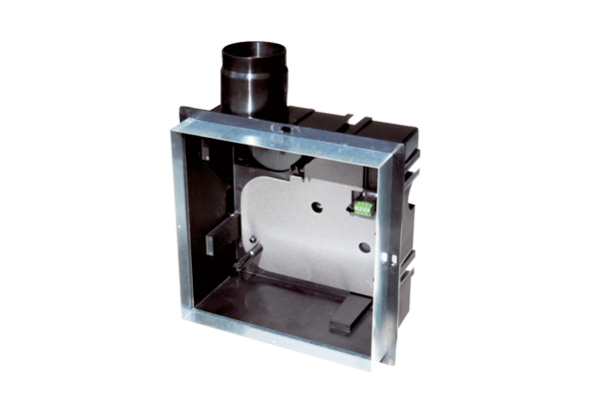Recessed-mounted housing ER GH-VWRPacking unit: 1 pieceRange: B
Article number: 0093.1564Manufacturer: MAICO

