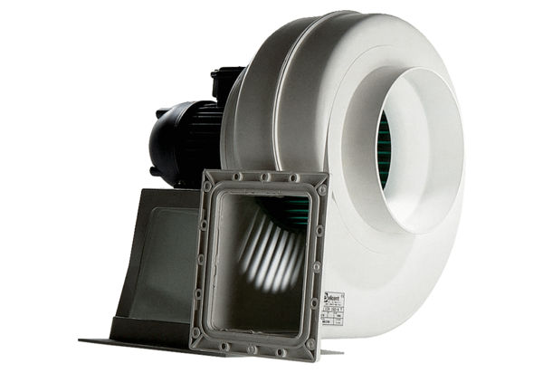Centrifugal blower GRK 25/4 DPacking unit: 1 pieceRange: C
Article number: 0073.0308Manufacturer: MAICO

