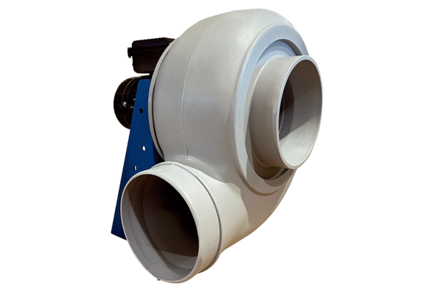Centrifugal blower GRK R 25/2 EPacking unit: 1 pieceRange: C
Article number: 0073.0505Manufacturer: MAICO

