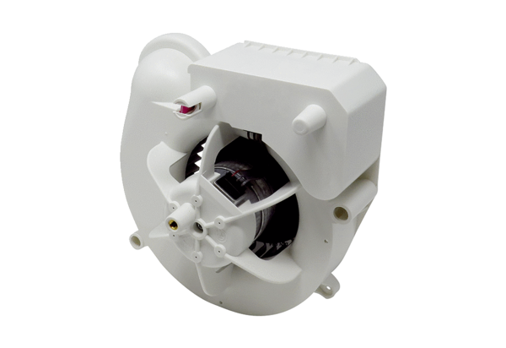Fan insert VE ER-AP 100 HRange: B
Article number: E084.0174.0000Manufacturer: MAICO

