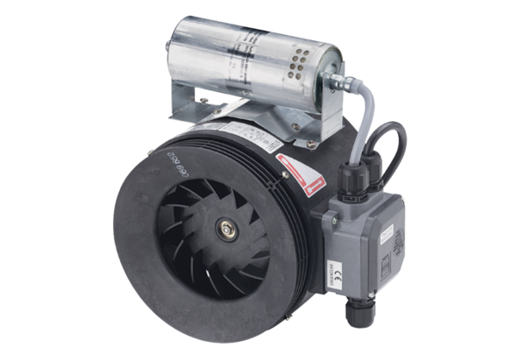Semi-centrifugal duct fan ERM 25 Ex ePacking unit: 1 pieceRange: C
Article number: 0080.0249Manufacturer: MAICO

