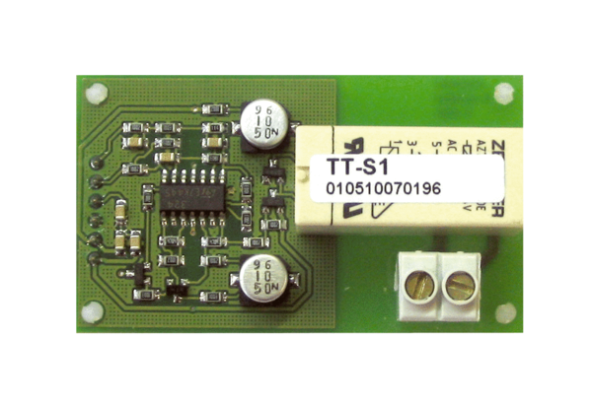Power board DTL 2 P-LPacking unit: 1 pieceRange: D
Article number: 0157.0587Manufacturer: MAICO

