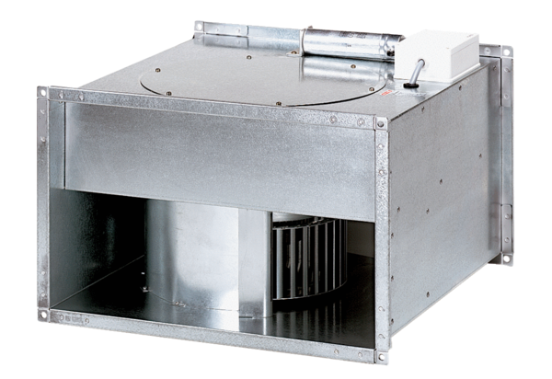Channel fan DPK 35/6 BPacking unit: 1 pieceRange: D
Article number: 0086.0668Manufacturer: MAICO

