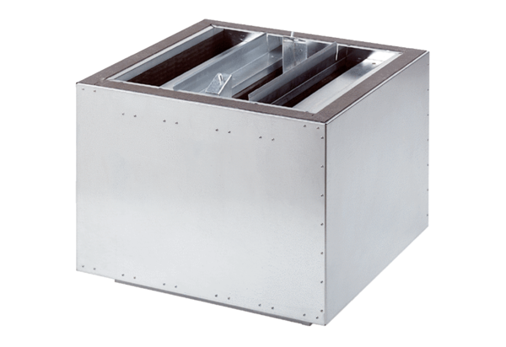Exhaust air silencer SDA 25Packing unit: 1 pieceRange: C
Article number: 0092.0387Manufacturer: MAICO

