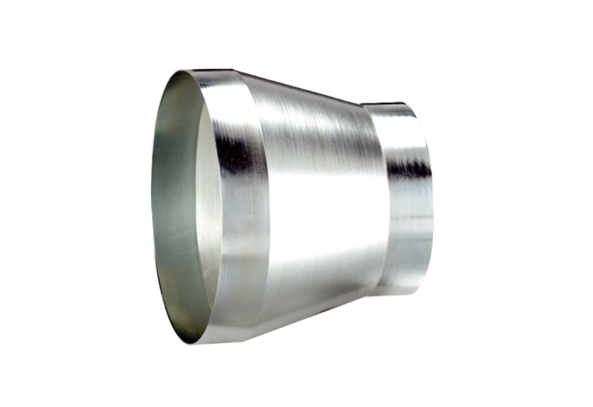Reducer REM 18/12 ExPacking unit: 1 pieceRange: C
Article number: 0055.0303Manufacturer: MAICO

