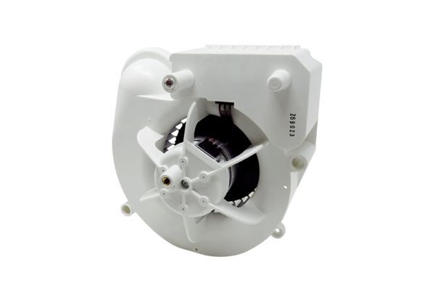Fan insert VE ER-APB 60 FRange: B
Article number: E084.0158.0000Manufacturer: MAICO

