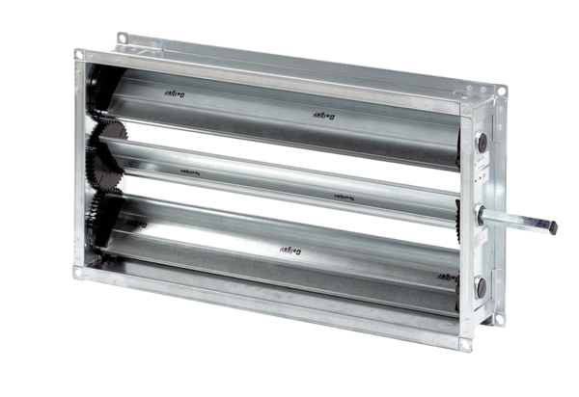Channel shutter RKP 31Packing unit: 1 pieceRange: D
Article number: 0151.0238Manufacturer: MAICO

