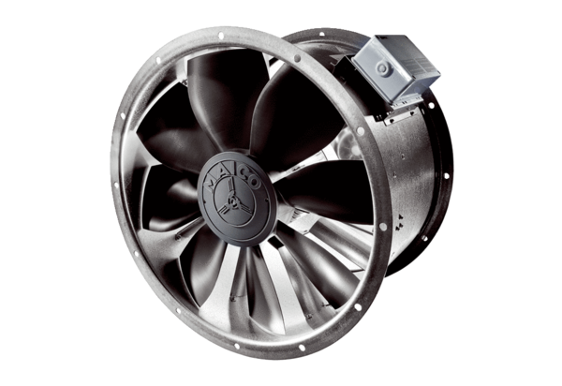Axial duct fan DZL 56/4 BPacking unit: 1 pieceRange: C
Article number: 0086.0090Manufacturer: MAICO

